Data Collection (Epic 1)
There are many popular open sources for collecting the data. Eg: kaggle.com, UCI repository, etc.
In this project we have used Floods_Data.csv data. This data is downloaded from kaggle.com. Please refer to the link given below to download the dataset.
Link: https://www.kaggle.com/datasets/arbethi/rainfall-dataset
Loading Data(USN2) 1
Our dataset format might be in .csv, excel files, .txt, .json, etc. We can read the dataset with the help of pandas.
In pandas we have a function called read_csv() to read the dataset. As a parameter we have to give the directory of csv file.
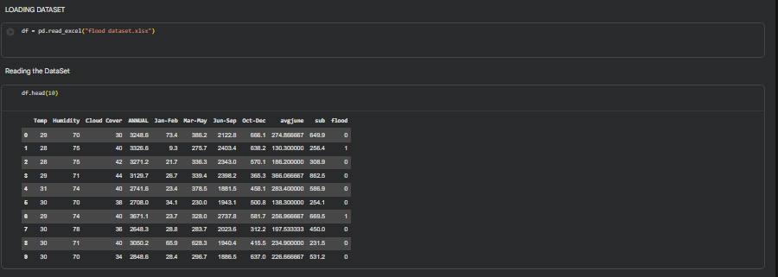

Data Preparation (Epic 2)
Handling Missing Values(USN3) 3
- For checking the null values, df.isnull() function is used. To sum those null values we use .sum() function to it. From the below image we found that there are no null values present in our dataset. So we can skip handling of missing values step.

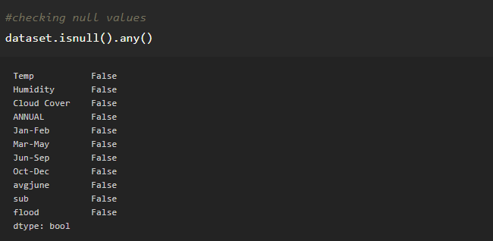

From the above code of analysis, we can infer that columns such as newbalanceOrg, oldbalnceOrig,isFraud are having the missing values, we need to treat them in a required way.

Total Story Point in Sprint 1= 2+1+3+3+3=12

Sprint 2
Data Visualization (Epic 3)
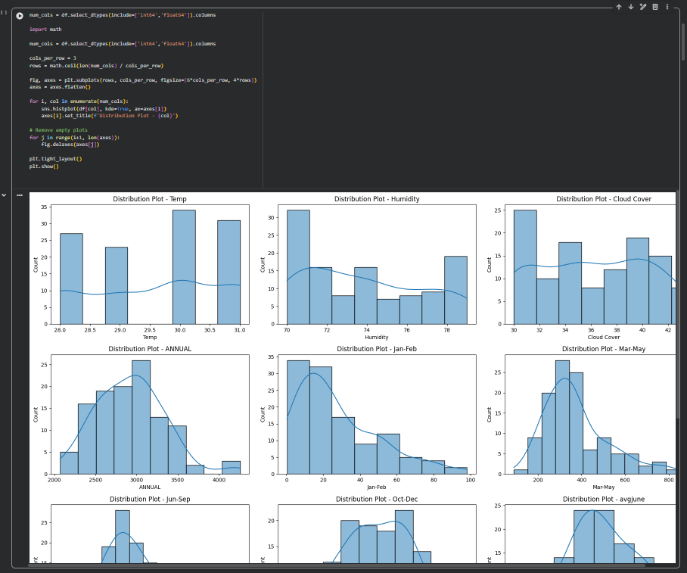

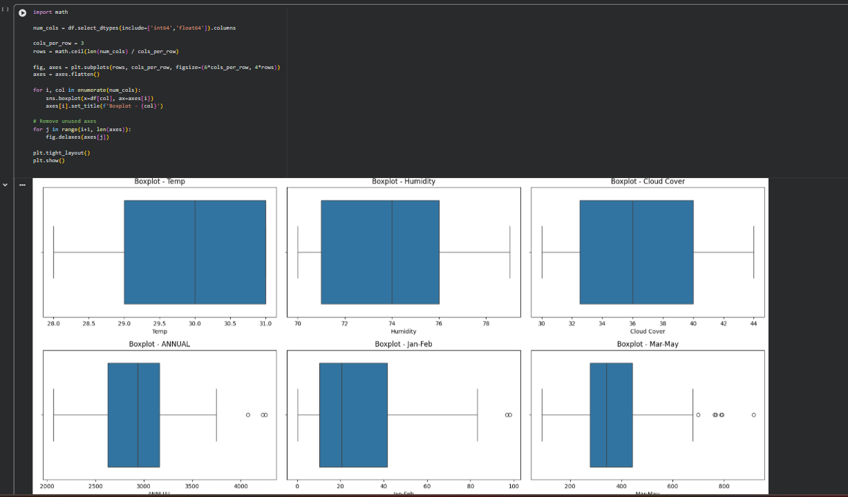
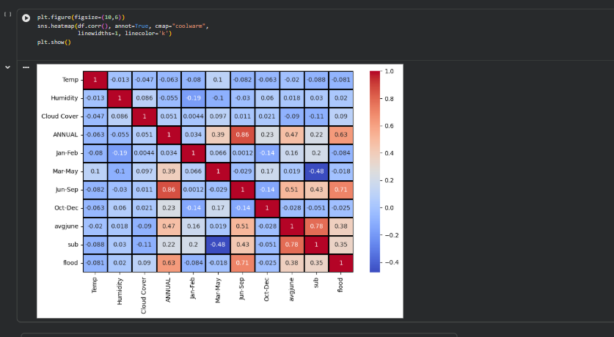
output (Epic 4)
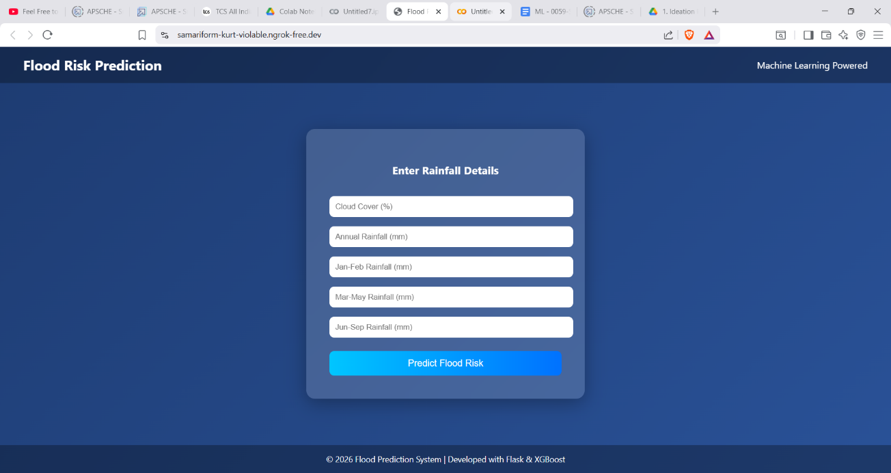

Story (Epic 5)
